ПОДОРОЖ 19. ORAL EXAM

At the Restaurant
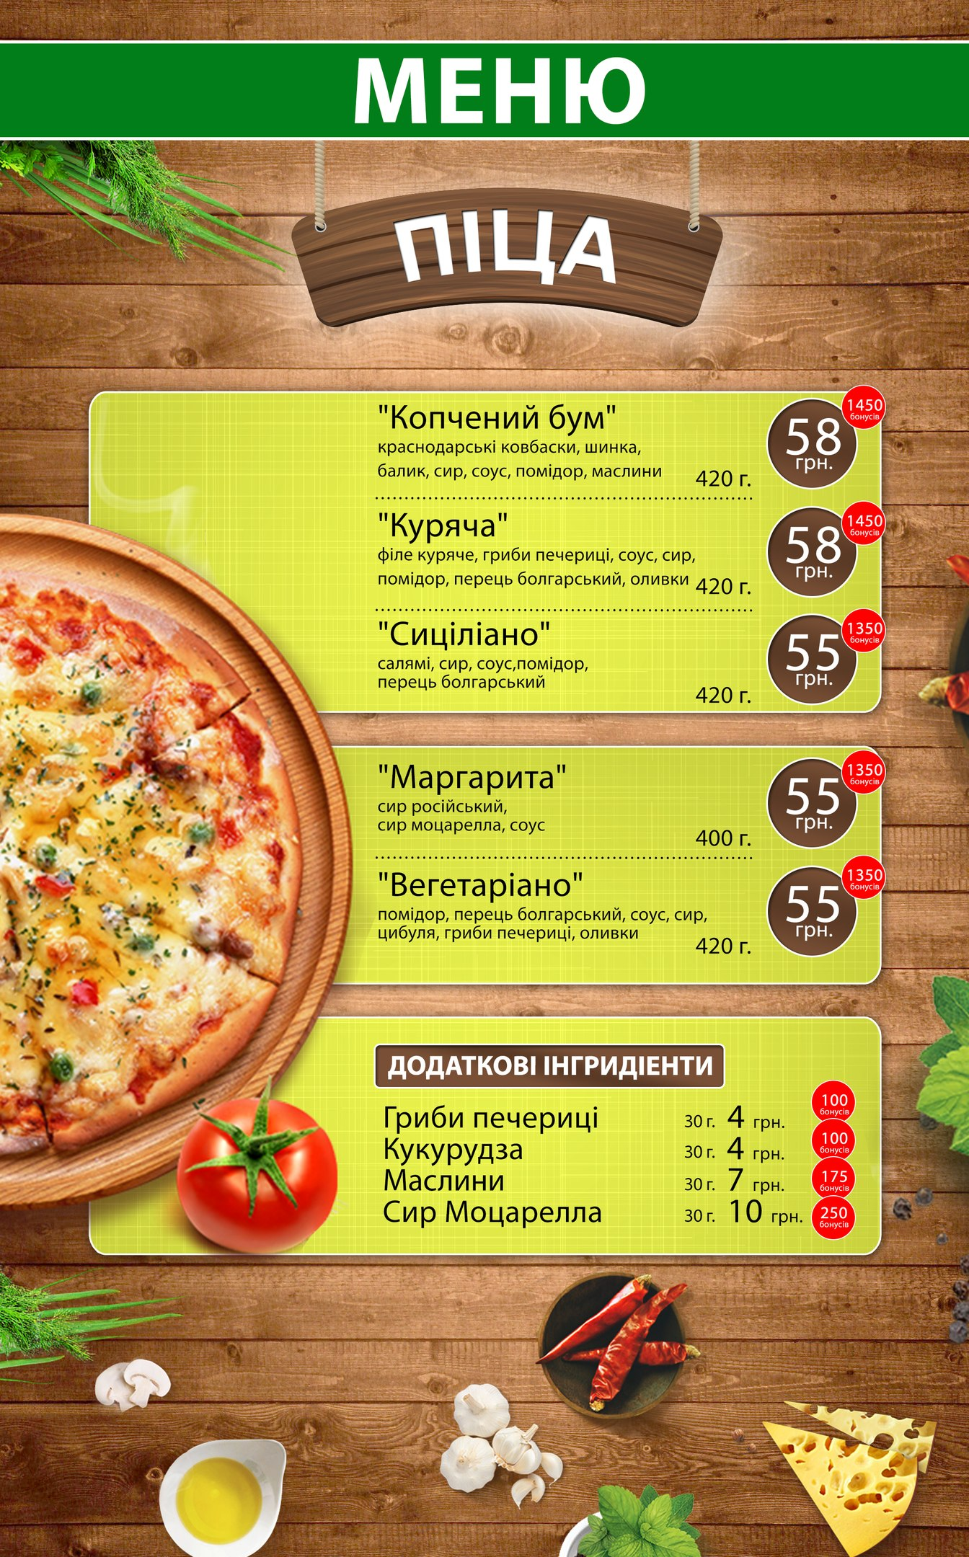 | 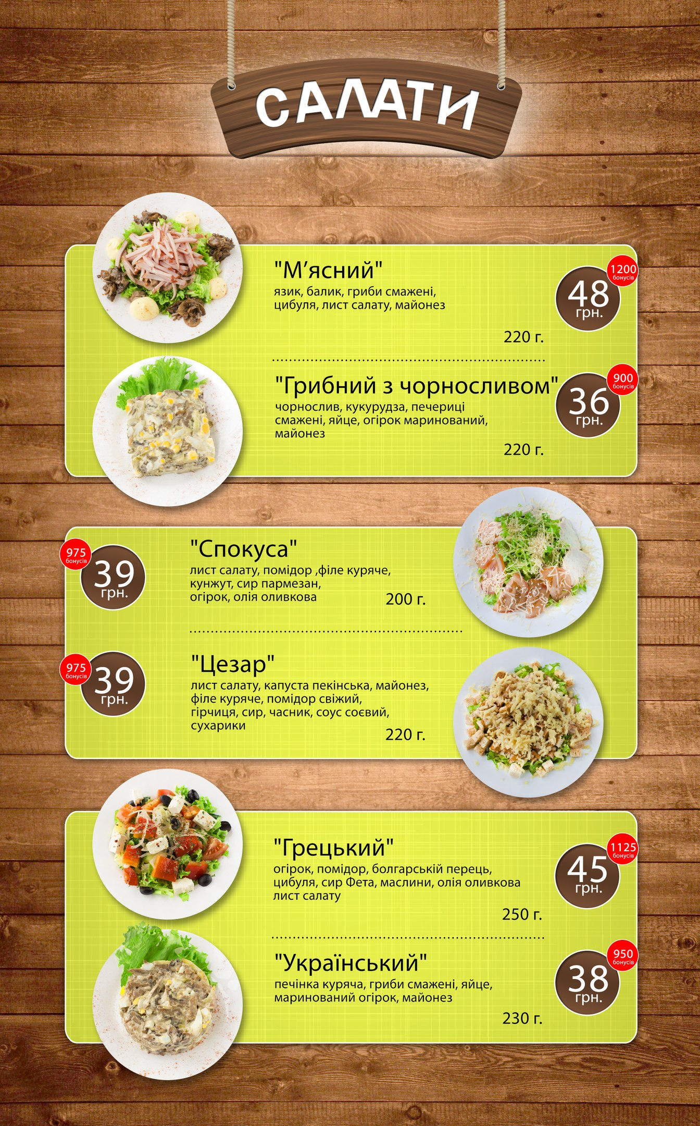
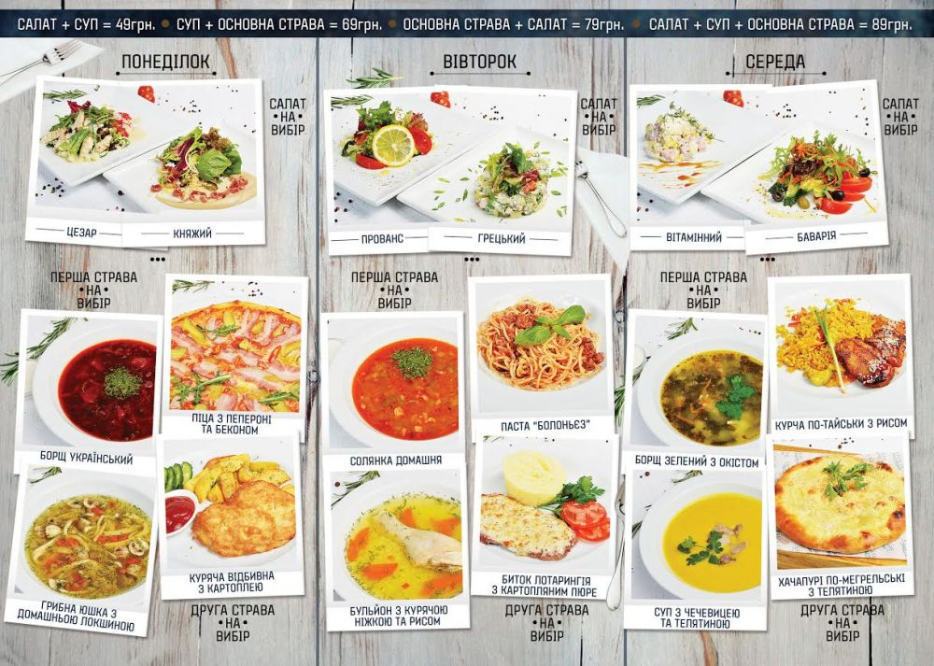

Photo credit: http://topclub.ua/blog/news/novye-biznes-lanchi-v-lkafa-cafe

